CodeChef Competitive Coding

Recruitment Tasks

Task 1 : Long words

Code :

a = int(input())

for i in range(1,a+1) :

str = input()

if len(str)>10 :

b = len(str)-2

print(f'{str[0]}{len(str)-2}{str[-1]}')

else :

print(str)

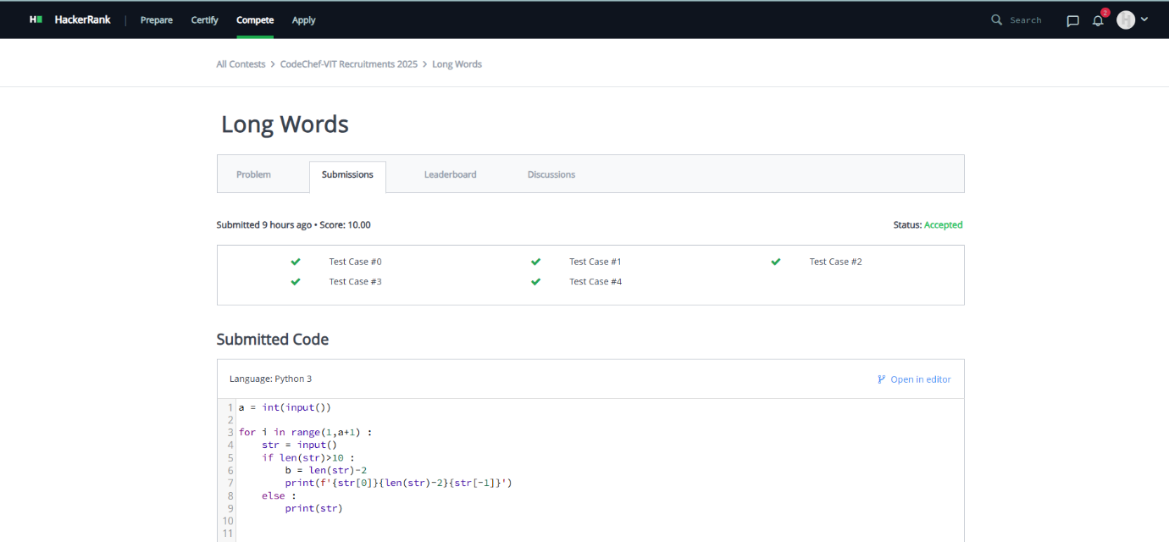

Task 2 : Chef’s Chaotic cookbook

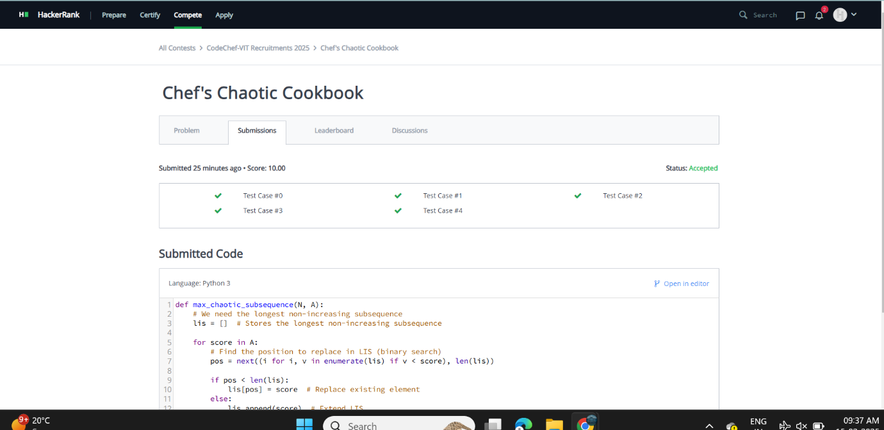

Task 3 :Special soup

dict = {'n':[],'t':['t'],'b':['b'],'o':['o'],'c':['t','b'],'p':['o','t'],'y':['o','b'],'s':['t','b','o']}

loop = int(input())

for I in range(loop):

n= int(input())

moves = 0

d = input()

list = [str(i) for i in d.split()]

if dict[list[0]].count('t')==1:

moves+=1

if dict[list[0]].count('o')==1:

moves+=1

if dict[list[0]].count('b')==1:

moves+=1

for i in range(n-1):

a = list[i]

b = list[i+1]

c = dict[b].count('t')-dict[a].count('t')

if c==0:

moves +=0

elif c== -1 :

moves+=1

for i in range(n-1):

a = list[i]

b = list[i+1]

c = dict[b].count('b')-dict[a].count('b')

if c==0:

moves +=0

elif c == -1:

moves+= 1

for i in range(n-1):

a = list[i]

b = list[i+1]

c = dict[b].count('o')-dict[a].count('o')

if c==0:

moves +=0

elif c== -1 :

moves+=1

print(moves)

